National Textile University, Faisalabad


Department of Computer Science
Name | Ghulam Habib
Class | BSSE 3rd
Section | A
Registration No | 24-NTU-CS-FL-1154
Assignment | Lab-6
Course Code | DS-2077
Course Name | Data Structures
Submitted To | Sir Basit
Submission Date | 11-October -2025

DATA STRUCTURES
Lab Plan – 6

Following is the declaration of Queue class and its member functions. Write the code to implement the definitions of these member functions by using Array and Link List

Node Code :

#ifndef H_node

#define H_node

#include <iostream>

using namespace std;

class node

{

int data;

node *next;

public:

node()

{

next = NULL;

data = 0;

}

void setData(int data)

{

this->data = data;

}

void setNext(node *next)

{

this->next = next;

}

int getData()

{

return data;

}

node *getNext()

{

return next;

}

};

#endif

Queue Logic Code :
#ifndef H_queue
#define H_queue
#include <iostream>
#include "Node.h"
using namespace std;
class queque
{
node * front;
node * rear;
int count;

public:
queque();
void enqueue(int);
void dequeue();
void printQueue();
bool isEmpty();
int getFront();
};
int queque::getFront()
{
if(front!=NULL)
{
return front->getData();
}
return -1;
}
bool queque::isEmpty()
{
return front==NULL;
}
void queque::printQueue()
{
node * curr=front;
while(curr!=NULL)
{
cout<<curr->getData()<<" ";
curr=curr->getNext();
}
cout<<endl;
}
void queque::dequeue()
{
if(front!=NULL)
{
node *temp=front;
front=front->getNext();
delete temp;
count--;
}
else{
cout<<"Empty queque\n";
}
}
queque::queque()
{
front=NULL;
rear=NULL;
count=0;
}
void queque::enqueue(int data)
{
node *newNode=new node();
newNode->setData(data);
newNode->setNext(NULL);
if(front==NULL)
{
front=newNode;
rear=newNode;
count++;
}
else{
rear->setNext(newNode);
rear=newNode;
count++;
}
}

#endif

Screenshot :
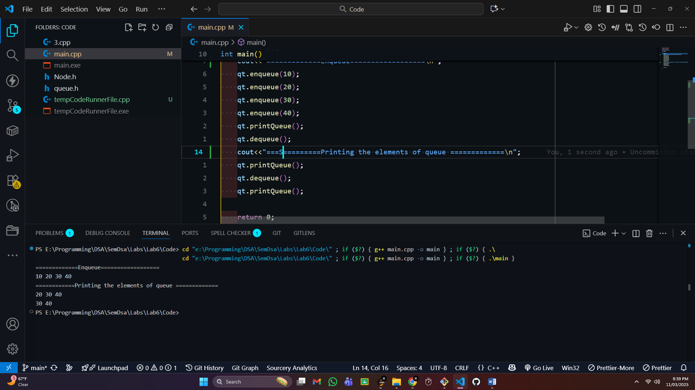

Exercise-2:

Test the Queue class with the following main() function:

Code :

#include <iostream>

#include "queue.h"

using namespace std;

int main()

{

queque qt;

qt.enqueue(10);

qt.enqueue(20);

qt.enqueue(30);

qt.enqueue(40);

qt.printQueue();

qt.dequeue();

qt.printQueue();

qt.dequeue();

qt.printQueue();

return 0;

}

Screenshot :


Exercise-3:

Test the code in the main() function by creating Object/s of List class.

Code:
#include <iostream>
#include "queue.h"
using namespace std;
int main()
{

queque qt;
int choice;
while (true)
{
cout<<"Insert Element into Queue(Press 1)\n";
cout<<"Delete element from queue(Press 2)\n";
cout<<"Display the queue(Press 3)\n";
cout<<"Exit(Press 4)\n";
cin>>choice;
if(choice==1)
{
int data;
cout<<"Enter Data \n";
cin>>data;
qt.enqueue(data);
}
else if(choice==2)
{

qt.dequeue();
cout<<"Element is Removed \n";

}
else if(choice==3)
{
qt.printQueue();
}
else if(choice==4)
{
break;
}
}

return 0;
}

Screenshot :
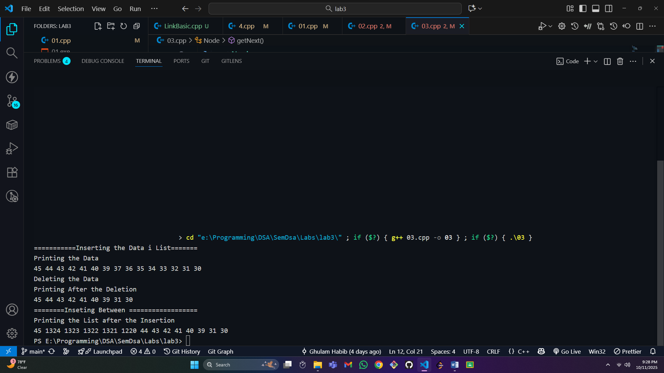

===================END===============

